Math 4 Name_______________________________

**5-3 Practice 2** Date________

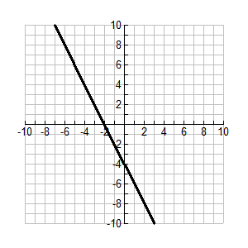1. Below is a graph of  Describe the graph of  using as much detail as possible.

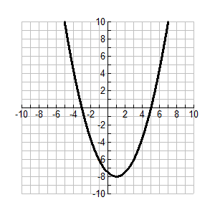2. Below is a graph of  Describe the graph of  using as much detail as possible.

3. Use the graph of below to give all the values where  is positive, negative and zero.

